import 'dart:io';

void main(){

print('Enter total bill amount:');

double? billAmount = double.tryParse(stdin.readLineSync()!);

print('Number of people:');

int? numberOfPeople = int.tryParse(stdin.readLineSync()!);

print('Enter tip percentage:');

double? tipPercentage = double.tryParse(stdin.readLineSync()!);

double perPerson = calculatePerPerson(billAmount, tipPercentage, numberOfPeople!);

print('Amount per person to be paid is: ₹$perPerson');

}

double calculatePerPerson(double? billAmount, double? tipPercentage, int people) {

if (billAmount == null || tipPercentage == null || people <= 0) {

print('Invalid input. Please enter valid numbers.');

return 0.0;

}

else{

double tipAmount = (billAmount \* tipPercentage / 100);

double totalWithTip = billAmount + tipAmount;

print('Tip Amount is : ₹$tipAmount');

print('Total Amount is: ₹$totalWithTip');

return totalWithTip / people;

}

}

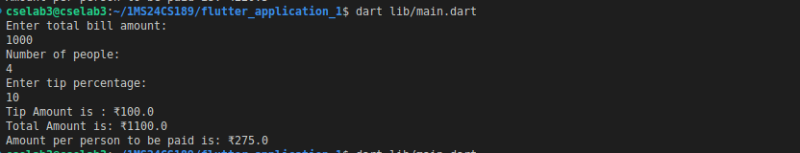

void main() {

// 1. Declare and initialize a list of maps

List<Map<String, dynamic>> moviebooking= [

{

'moviename': 'IronMan',

'ticketsbooked': 30,

'priceperticket': 100.0,

},

{

'moviename': 'Avengers',

'ticketsbooked': 50,

'priceperticket': 150.0,

},

{

'moviename': 'SpiderMan',

'ticketsbooked': 20,

'priceperticket': 120.0,

},

{

'moviename': 'Batman',

'ticketsbooked': 25,

'priceperticket': 130.0,

},

];

// 2. Calculate total revenue

double totalRevenue = 0.0;

print('----------------Movie Ticket Summary-----------------');

for(final booking in moviebooking) {

double revenue = booking['ticketsbooked'] \* booking['priceperticket'];

totalRevenue += revenue;

print('Movie: ${booking['moviename']}');

print('Tickets Booked: ${booking['ticketsbooked']}');

print('Price per Ticket:${booking['priceperticket']}');

print('Revenue: ₹$revenue');

}

print('-----------------------------------------------------');

print('Total Revenue from all movies: ₹$totalRevenue');

}

